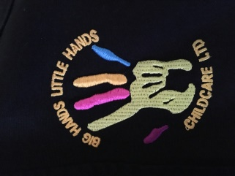

Did You Know…?

We are now online! Check out our Facebook: BigHandsLittleHandsChildcareLtd.

And website www.bighandslittlehandschildcare.co.uk

please give us a review!

**Key Workers**

Shotley Medomsley

Anna - Reception & Year 1 Rachael – R, 1 &2

Alex – Years 2 and 3 Alex – Year 3 & 4

Steph – Years 4, 5 and 6 Anna – Year 5 & 6

**Reviews and Improvements**

We are always looking for ways to improve so would welcome your feedback in our new comments box, kept on the staff desk. We have also been involving the children by discussing things they like or dislike at the club.

**Holiday Club**

Big Hands Little Hands Childcare offers Holiday Club for every school holiday, based at Medomsley school and is open to all children.

Easter Holidays 10th- 21st April inclusive.

Opening Hours 8am-5:30pm

Lots of indoor and outdoor activities.

Breakfast, 2 course Lunch and Snacks included

**Staff Changes**

In January we welcomed a new member of staff to our team. Anna will be working breakfast, after school club and holiday club and has already made some great bonds with our children.

Rachael will be working full time as

Deputy Manager for the Medomsley

setting.

All of our staff attend regular training courses to ensure they are up to date in all aspects of childcare.

**Farewell!**

The end of 2016 saw some tearful goodbye’s as we lost two of our wonderful staff. Sarah has left to work full time for Medomsley School and Ceri emigrated to Australia. We wish them both the very best of luck for the future!

A huge welcome to parents new and old of Big Hands Little Hands Childcare Ltd.! Now that spring has sprung, we can breathe a little sign of relief that we shouldn’t get caught out in the snow and ice on Church bank anymore! We are really looking forward to some sunshine!

Spring Newsletter

**Big Hands**

**Little Hands**

**Childcare**

**Ltd.**