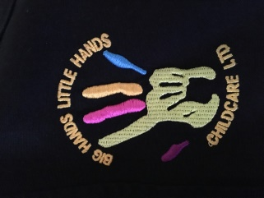

**Our Facebook Page**

As many of you will now have noticed, we have our own Facebook page where we will be posting updates of our activities and/ or future plans. We would love it if as many as possible of our parents (and their friends!) could like our page and give us a review as it would be a great help to the business.

Thanks!

**Reviews and Improvements**

All of our staff undertakes regular training to ensure we are compliant with the most up to date regulations and to provide the best possible level of care for your children.

Recently Steph, Rachael and Anna have refreshed their safeguarding training. Anna has been on a course designed to give practical ideas for our setting and we have all undergone prevent terrorism training.

We are also very proud to announce, both Shotley and Medomsley settings received a level 5 (the best!) food hygiene certificate.

**Farewell!**

At the end of this school term we will be saying goodbye to some of our wonderful children. Our year 6’s will be leaving to go up to senior school and some of our year 4’s will be off to Corbridge. We wish them all the very best of luck for the future!

**Holiday Club**

As another summer holiday approaches, we are gearing up for Holiday Club once again. We already have lots of exciting plans including trips to the beach, farm and park. Look out for our Holiday Club Itinerary out now!

Summer Holidays 24th July- 1st September.

Opening Hours 8am-5:30pm

Lots of indoor and outdoor activities.

Breakfast, 2 course Lunch and Snacks included

To book a place, please contact Bev on 07745086793 or speak to one of the girls at Club.

Summer Newsletter

Did You Know…?

We are now online! Check out our Facebook: BigHandsLittleHandsChildcareLtd.

And website www.bighandslittlehandschildcare.co.uk

Wow! It’s hard to believe we are almost at the end of another school year already. As everyone is winding down, we are just gearing up for a busy summer holiday at Holiday Club!

**Big Hands**

**Little Hands**

**Childcare**

**Ltd.**