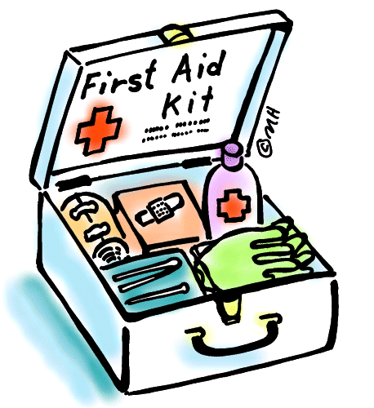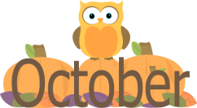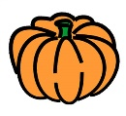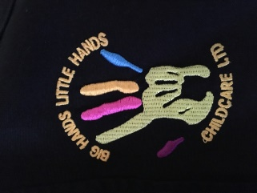

**Comments and Suggestions…**

Please don’t forget that we are continually striving for improvement so if you have any comments or suggestions (or even requests from your children for activities they would like to do), please pop them into our ‘Comments Box’ on the staff table.

**Key Workers**

Shotley Medomsley

Anna - Reception & Year 1 Rachael – R, 1 &2

Alex – Years 2 and 3 Alex – Year 3 & 4

Steph – Years 4, 5 and 6 Anna – Year 5 & 6

**First Aid for Parents**

Mini First Aid are offering 2 hour small group classes for parents and will cover choking, CPR, bleeding, breaks, burns and more. Classes cost £20 per person and because we believe it is such an important skill to learn, if anyone would be interested in taking part in this course Big Hands Little Hands Childcare would be willing to cover the costs of renting the hall for you, if parents pay for their place on the course.

**Christmas Photo Shoot**

We are looking into offering a Christmas Photoshoot for the first time this year so would like to gage if there is any interest from parents. We have been working with a local professional photographer (the same lady who did our lovely business photoshoot during the summer holidays!) to design a package to appeal to you all.

The photoshoot would be **free** and all edited digital images of your child/children could be purchased for just £15!

We are looking at either Monday 23rd October (first day of Holiday Club) or one evening during November. Please do get in touch if you would be interested and let us know which date you would prefer!

**October Half Term**

Holiday Club is taking bookings now for half term. We have lots of fun activities planned including crafts, baking, games, sports and more! Priced at just £25 per day, including breakfast, 2 course lunch and afternoon snacks.

Holiday Club is open every school holiday for children from all schools. Speak to Bev or one of the girls at your setting about our special offers and to book a place.

So, the dark nights are creeping up on us and the leaves are falling. And while that may mean the end of summer (boo!) we have lots to look forward to over the coming months. We have already had some great autumnal fun- from blackberry picking for our apple and blackberry crumble to painting some fabulous autumn trees and, of course, we just couldn’t resist crunching and stomping around in all those leaves!

October Newsletter

**Big Hands**

**Little Hands**

**Childcare**

**Ltd.**