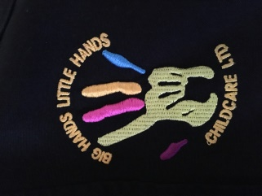

**Snow Days!**

We realise that parents may be concerned about childcare should the schools close due to bad weather so we will be extending our offer for full day childcare for just £25 per child (rather than our standard £6ph childminding fee). Please contact Bev on 07745086793 as early as possible on the day cover is required as places are limited.

Should schools close part way through the day, we are also able to offer early pick ups!

**First Aid Fundraising**

A huge thank you to everyone who bought or sold raffle tickets for our First Aid fundraising efforts! We managed to raise a fantastic £607!

We are hoping to hold a bag pack in the near future and will be looking for volunteers (parents or children!) to join us one Saturday to continue our fundraising efforts. Please get in touch if you or your child would like to help.

**Changes to Payments**

* As of 1st February 2018, we will no longer be accepting payments made via cheque. Payments can still be made in Cash or via bank transfer.
* Due to an increase in requests for statements and childcare bursary forms completing, we are going to need to introduce a minimal administration fee of £5 per request to cover the time it takes to prepare.
* Payments should be made no later than 30 days from the date of invoice and unfortunately, due to an increase in late or missing payments, we will be introducing a late payment fee. Repeated failure to pay invoices will lead to childcare being stopped (although we really don’t ever want this to happen!)

**Holiday Club**

We are now taking bookings for February Half Term Holiday Club. We have lots of exciting activities planned and will be celebrating Valentine’s Day and Chinese New Year!

Half Term Holidays 12th-16th Feb 2018.

Opening Hours 8am-5:30pm

Lots of indoor and outdoor activities.

Breakfast, 2 course Lunch and Snacks included

To book a place, please contact Bev on 07745086793 or speak to one of the girls at Club.

**The past 12 months…**

We just wanted to take a moment to reflect on the last 12 months at Big Hands Little Hands Childcare. 2017 has been a great year for us and we are really proud of how much we have accomplished. We have gained two new members of staff, set up our Facebook Page and new website, made brand new flyers, bought a branded minibus to start offering childcare to additional schools, created a ‘Friends of’ group and even managed to squeeze in a last minute move to our new office premises before the end of the year! So while it has been busy, we have lots to be thankful for.

We would like to extend a huge thank you to our customers for all of your support and we look forward to another great year in 2018.

January Newsletter

We hope you have all had a brilliant Christmas and New Year and it hasn’t been too hard getting back in to the school routine!

**Big Hands**

**Little Hands**

**Childcare**

**Ltd.**