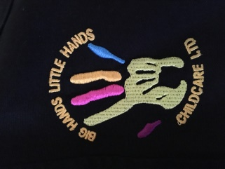

**OFSTED**

We are pleased to announce that our Medomsley setting was awarded a ‘Good’ during our recent OFSTED inspection. The inspector noted that the ‘Children have lots of fun and feel secure in the warm, welcoming and supportive setting.’ She also commented that the ‘children behave exceptionally well’ so a huge well done to all of our staff and children! Our Shotley Bridge OFSTED will be announced soon too.

**Social Media**

Social Media is a great way for us to show all of our parents some of the great activities we get up to during after school club and holiday club, as well as getting a message out quickly if we need to (especially once the weather gets better and we can have impromptu picnics outside!) Please do like our page then like, share or react to our posts to ensure you get to see us in your news feed!

Facebook: @BigHandsLittleHandsChildcare

Instagram: @bighandslittlehandschildcare



Well the old saying “April showers bring May flowers” went to the extreme this year with our first snow covered Easter Holiday Club followed by a fantastically sunny bank holiday! We all managed to have a brilliant time regardless and if you’ve been following our Facebook, you’re sure to have seen some of the activities the children participated in over the last few months.

**Bank Transfer Payments**

Just a quick note to let you know that invoices will become due within 14 days of the invoice date, starting after half term. This replaces the current 30 day window for payment.

**Children’s First Aid**

We held our first FREE children’s first aid during the Easter Holidays with great feedback from the children. They learned a variety of skills including CPR, cut and burn treatments and what to do in an emergency. Certificates will be ready to be collected for those who took part soon.

The next set of session times will be announced soon!

**Congratulations Alex!**

We hope you will join us in wishing our lovely Alex a huge ‘Congratulations!’ on the birth of her baby boy, Hudson. Mum and baby are doing well and all of the staff and children can’t wait to meet him.

**Holiday Club**

We are now taking bookings for May

Half Term Holiday Club. We have lots of exciting activities planned, as always!

Half Term Holidays 28th May-4th June 2018.

Opening Hours 8am-5:30pm

Lots of indoor and outdoor activities.

Breakfast, 2 Course Lunch and Snacks included

To book a place, please contact Bev on 07745086793 or speak to one of the girls at Club.

May Newsletter

**Big Hands**

**Little Hands**

**Childcare**

**Ltd.**